* Copyright for test papers and marking guides remains with *West Australian Test Papers*.
* The papers may only be reproduced within the purchasing school according to the advertised conditions of sale.
* Test papers must be withdrawn after use and stored securely in the school until Friday 4th December

**HUMAN BIOLOGY**

**Unit 1 and 2**

**2020**



Name: _______________________________________________________

Teacher: ___________________________________________________

**Time allowed for this paper**

Reading time before commencing work: ten minutes

Working time: three hours

**Materials required/recommended for this paper**

***To be provided by the supervisor***

This Question/Answer booklet

Multiple-choice answer sheet

***To be provided by the candidate***

Standard items: pens (blue/black preferred), pencils (including coloured), sharpener, correction fluid/tape, eraser, ruler, highlighters

Special items: non-programmable calculators approved for use in this examination

**Important note to candidates**

No other items may be taken into the examination room. It is **your** responsibility to ensure that you do not have any unauthorised material. If you have any unauthorised material with you, hand it to the supervisor **before** reading any further.

**Structure of this paper**

|  |  |  |  |  |  |
| --- | --- | --- | --- | --- | --- |
| Section | Number of questions available | Number of questions to be answered | Suggested working time (minutes) | Marks available | Percentage of examination |
| Section One Multiple-choice | 30 | 30 | 40 | 30 | 30 |
| Section Two Short answer | 8 | 8 | 90 | 115 | 50 |
| Section Three Extended answer  Unit 1 | 2 | 1 | 50 | 40 | 20 |
| Unit 2 | 2 | 1 |  |  |  |
|  |  |  |  | **Total** | 100 |

**Instructions to candidates**

1. The rules for the conduct of the Western Australian examinations are detailed in the *Year 12 Information Handbook 2020*. Sitting this examination implies that you agree to abide by these rules.

2. Write your answers in this Question/Answer booklet preferably using a blue/black pen. Do not use erasable or gel pens.

3. Answer the questions according to the following instructions.

Section One: Answer all questions on the separate Multiple-choice answer sheet provided. For each question, shade the box to indicate your answer. Only use a blue or black pen to shade the boxes. Do not use erasable or gel pens. If you make a mistake, place a cross through that square, then shade your new answer. Do not erase or use correction fluid/tape. Marks will not be deducted for incorrect answers. No marks will be given if more than one answer is completed for any question.

Section Two: Write your answers in this Question/Answer booklet. Wherever possible, confine your answers to the line spaces provided.

Section Three: Consists of two parts each with two questions. You must answer one question from each part. Tick the box next to the question you are answering.

Write your answers in this Question/Answer booklet

4. You must be careful to confine your answers to the specific questions asked and to follow any instructions that are specific to a particular question.

5. Supplementary pages for planning/continuing your answers to questions are provided at the end of this Question/Answer booklet. If you use these pages to continue an answer, indicate at the original answer where the answer is continued, i.e. give the page number.

**Section One: Multiple-choice 30% (30 Marks)**

This section has **30** questions. Answer **all** questions on the separate Multiple-choice answer sheet provided. For each question shade the box to indicate your answer. Use only a blue or black pen to shade the boxes. Do not use erasable or gel pens. If you make a mistake, place a cross through that square, then shade your new answer. Do not erase or use correction fluid/tape. Marks will not be deducted for incorrect answers. No marks will be given if more than one answer is completed for any question.

Suggested working time: 40 minutes.

1. Cellular respiration can be described as
   1. a catabolic reaction.
   2. a synthesis reaction.
   3. an anabolic reaction.
   4. a growth reaction.
2. Contraction of a sarcomere involves
   1. Z lines moving further apart.
   2. A bands crossing over.
   3. actin sliding over myosin.
   4. actin and myosin changing in length.
3. In which of the following parts of the body would you expect to find the greatest number

of Golgi bodies?

* 1. Muscles
  2. Salivary glands
  3. Small intestine
  4. Stomach

1. An allele that is expressed in a heterozygous genotype is known as
   1. genotypic.
   2. recessive.
   3. co-dominant.
   4. dominant.

Questions 5, 6 and 7 refer to the diagram below.

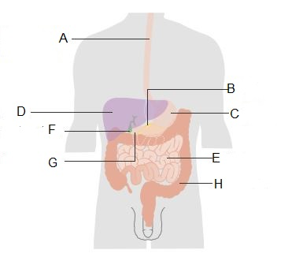

1. The diagram above shows the human digestive system. Which description best describes

its function?

* 1. Elimination and excretion of waste products
  2. Breakdown of food and absorption of nutrients
  3. The production of energy for cells
  4. Breakdown of food and excretion of waste products

1. The structure labelled as E is the
   1. liver.
   2. stomach.
   3. large intestine.
   4. small intestine.
2. The function of the structure labelled D is
   1. secretion of digestive enzymes.
   2. production of bile.
   3. storage of bile.
   4. elimination of waste products.
3. A patient with blood type O requires a transfusion. Which of the following lists the

blood types that this patient can receive?

1. Blood types A and O
2. Blood types AB and A
3. Blood type O only
4. Blood types AB, A and O
5. In fertilisation two gametes fuse together to form
   1. a zygote.
   2. an embryo.
   3. a clone.
   4. a foetus.
6. The equation for aerobic respiration is:

Glucose + X Energy + Carbon dioxide + Y

Which of the following correctly identifies X and Y?

|  |  |  |
| --- | --- | --- |
|  | **X** | **Y** |
| (a) | Oxygen | Lactic acid |
| (b) | Oxygen | Water |
| (c) | Water | Oxygen |
| (d) | Water | Lactic acid |

1. Which of the following molecules can be joined together to form a nucleotide that

would be part of DNA?

1. Adenine

2. Phosphate

3. Ribose sugar

4. Uracil

5. Deoxyribose sugar

* 1. 1, 2 and 4
  2. 2, 3 and 5
  3. 1, 2 and 5

1. 2, 3 and 4
2. What is the likely fertile period for a woman with a menstrual cycle that has an

average time span of 28 days?

(a) Days 1-10

(b) Days 11-16

(c) Days 17-21

(d) Days 21-28

1. In which direction does blood flow in the umbilical artery and umbilical vein?

|  |  |  |
| --- | --- | --- |
|  | **Umbilical artery** | **Umbilical vein** |
| (a) | Towards the foetus | Towards the mother |
| (b) | Away from the foetus | Towards the mother |
| (c) | Away from the foetus | Away from the mother |
| (d) | Towards the foetus | Away from the mother |

Questions 14 and 15 refer to the diagram below.

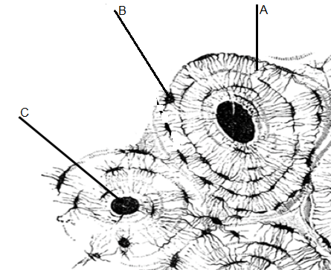

1. The structure labelled as B is a small space found within the bone matrix. What name is

given to this structure?

* 1. Osteon
  2. Canaliculi
  3. Lamellae
  4. Lacunae

1. The structure labelled as C is the
   1. Haversian canal.
   2. lamellae.
   3. osteocyte.
   4. trabeculae.
2. The chorionic villi are
   1. finger-like projections that project outwards from the intestinal walls.
   2. finger-like projections containing embryonic blood capillaries that grow into the endometrium.
   3. structures containing both embryonic and maternal tissue.
   4. structures that attach the embryo to the placenta throughout pregnancy.

Questions 17,18 and 19 refer to the diagram below, which shows the inheritance of a disorder within a family.

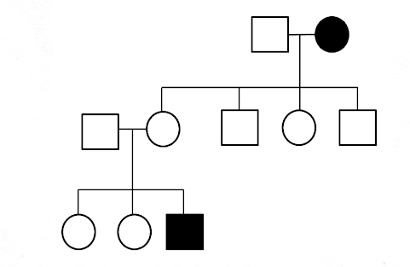

2

3

5

4

3

2

1

1

2

1

III

II

I

1. The mode of inheritance depicted above is
   1. autosomal recessive.
   2. sex-linked recessive.
   3. autosomal dominant.
   4. sex-linked dominant.
2. The **best** evidence from this pedigree that depicts the mode of inheritance is
   1. an affected parent has an unaffected child.
   2. the trait appears in males and females in equal numbers.
   3. the trait skips generations.
   4. two unaffected parents have an affected offspring.
3. If individuals II1 and II2 were to have another child, what would be the chance of the

child being affected by this disorder?

* 1. 100%
  2. 75%
  3. 50%
  4. 25%

1. What characteristic of arteries enables them to withstand the high velocity and pressure

of blood?

* 1. Large lumen
  2. One-cell thick wall
  3. Thick endometrial layer
  4. Thick muscular layer

1. Athletes drink glucose-enriched drinks because

* 1. glucose has the highest energy value of any nutrient.
  2. glucose does not need digesting and is quickly absorbed.
  3. energy is used up in digestion.
  4. it passes most quickly into the stomach where it can be absorbed.

1. As a blood cell travels from the renal vein to the aorta, how many times will it pass

through the heart on its journey?

* 1. No times
  2. Once
  3. Twice
  4. Three times

1. Which component of faeces is an excretory product?

* 1. Bacteria
  2. Cellulose
  3. Undigested food
  4. Bile pigments

1. What path does sperm take from where it is produced to where it fertilises an egg?
   1. Testis, sperm duct, urethra, vagina, oviduct
   2. Testis, urethra, sperm duct, vagina, cervix
   3. Prostrate, testis, sperm duct, oviduct, vagina
   4. Scrotum, testis, sperm duct, vagina, uterus
2. Proteins that are found within chromosomes and are closely associated with gene

expression are called

* 1. histones.
  2. mutations.
  3. genes.
  4. centrioles.

1. Which of the following correctly shows the basic units of carbohydrates and proteins?

|  |  |  |
| --- | --- | --- |
|  | **Carbohydrates** | **Proteins** |
| (a) | Sucrose | Polypeptide |
| (b) | Amino acids | Fatty acids |
| (c) | Carbon | Nitrogen |
| (d) | Glucose | Amino acids |

1. Anticodons pair with
   1. amino acids.
   2. mRNA codons.
   3. DNA codons.
   4. ribosomes.
2. Which of the following correctly states a difference between osmosis and diffusion?

|  |  |  |
| --- | --- | --- |
|  | **Osmosis** | **Diffusion** |
| (a) | Does not require a semi- permeable membrane | Requires a semi-permeable membrane |
| (b) | Does not require energy | Requires energy |
| (c) | Only involves water  molecules | Does not only involve water molecules |
| (d) | Moves molecules against a concentration gradient | Moves molecules along a concentration gradient |

29. The first milk secretion produced by the breast after birth is known as

* 1. lactation.
  2. colostrum.
  3. antibodies.
  4. lobules.

30. An example of a physical contraceptive barrier is

1. an IUD.
2. the pill.
3. a condom.
4. a spermicide.

**End of Section One**

**Section Two: Short answer 50% (115 Marks)**

This section has **eight** questions. Answer **all** questions. Write your answers in the spaces provided.

Supplementary pages for planning/continuing your answers to questions are provided at the end of this Question/Answer booklet. If you use these pages to continue an answer, indicate at the original answer where the answer is continued, i.e. give the page number.

Suggested working time: 90 minutes.

**Question 31 (17 marks)**

The diagram below shows the direction of movement of two different substances through the plasma membrane of a cell.

(a) Identify (2 marks)

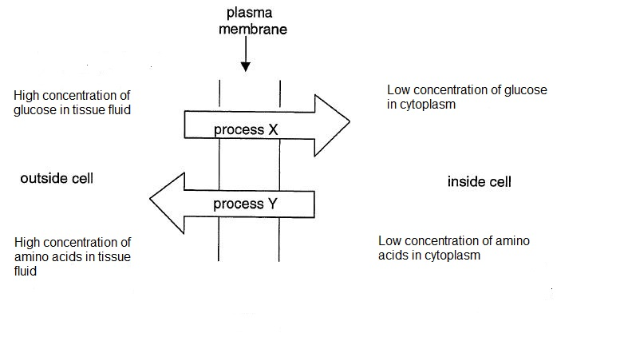

(i) Process X ________________________________________________

(ii) Process Y ________________________________________________

(b) Which of the processes X and Y would be affected by the amount of oxygen present in the blood plasma? Justify your choice. (3 marks)

___________________________________________________________________

___________________________________________________________________

___________________________________________________________________

___________________________________________________________________

(c) Name **two** other methods by which substances move across plasma cell membranes. (2 marks)

__________________________________________________________________

__________________________________________________________________

(d) Cell membranes are composed of protein and lipid molecules.

(i) On the diagram below, clearly label three cell organelles that would be involved in the synthesis of protein molecules that may form part of the cell membrane. (3 marks)

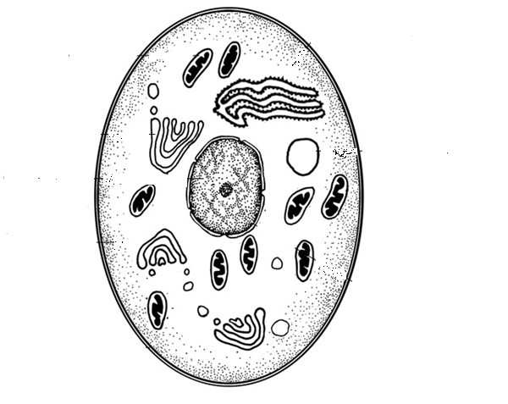

(ii) Briefly describe how each of the organelles you have labelled contributes to

protein synthesis in the cell. (3 marks)

______________________________________________________________

______________________________________________________________

______________________________________________________________

______________________________________________________________

______________________________________________________________

______________________________________________________________

______________________________________________________________

Enzymes are an example of a protein produced by a cell. They are used as catalysts for

reactions.

(e) Explain how enzymes catalyse specific reactions. (4 marks)

___________________________________________________________________

___________________________________________________________________

___________________________________________________________________

___________________________________________________________________

___________________________________________________________________

___________________________________________________________________

___________________________________________________________________

**Question 32 (17 marks)**

The table below gives the relative amounts of DNA present in different cells found within a human body.

|  |  |
| --- | --- |
| **Cell type** | **Amount of DNA** |
| Red blood cell | 0 |
| Skin cell | 6.6 |
| Ovum | 3.3 |

(a) Account for the fact that the DNA content of a red blood cell is zero. (1 mark)

___________________________________________________________________

___________________________________________________________________

___________________________________________________________________

(b) What is the relationship between the DNA content found in a skin cell and ovum? Give an explanation for this difference. (3 marks)

___________________________________________________________________

___________________________________________________________________

___________________________________________________________________

___________________________________________________________________

(c) The process of meiosis is involved in the production of gametes. What are the

two forms of gametogenesis called and explain how they differ in the number of

gametes they produce. (4 marks)

___________________________________________________________________

________________________________________________________________­___

___________________________________________________________________

___________________________________________________________________

___________________________________________________________________

___________________________________________________________________

___________________________________________________________________

___________________________________________________________________

(d) Sperm production occurs within the testes. Name the structure in which this process takes place and give an advantage of this structure being tightly coiled. (2 marks)

___________________________________________________________________

___________________________________________________________________

___________________________________________________________________

(e) State two structural differences between a sperm and an egg and for each difference explain how it helps in the process of reproduction. (4 marks)

1. Difference

___________________________________________________________________

Explanation ___________________________________________________________________

___________________________________________________________________

2. Difference

___________________________________________________________________

Explanation

___________________________________________________________________

___________________________________________________________________

(f) Explain the importance of fertilisation in sexual reproduction. (3 marks)

___________________________________________________________________

___________________________________________________________________

___________________________________________________________________

___________________________________________________________________

___________________________________________________________________

___________________________________________________________________

**Question 33 (14 marks)**

In humans, oxygen is carried around the body in chemical combination with an iron-based compound called haemoglobin. The chemical equation for haemoglobin combining with oxygen is shown below.

Hb + O2 HbO2 (this occurs in the lungs)

HbO2 Hb + O2 (this occurs in the body tissues)

The data below shows the relationship between the partial pressure (pp) of oxygen and the saturation of the haemoglobin molecule.

|  |  |
| --- | --- |
| **Partial pressure of oxygen (mm Hg)** | **Saturation of haemoglobin (%)** |
| 0 | 0 |
| 10 | 10 |
| 20 | 25 |
| 40 | 70 |
| 50 | 82 |
| 70 | 93 |
| 90 | 96 |

1. Identify the independent variable in the information shown above. (1 mark)

___________________________________________________________________

(b) Propose a hypothesis for this study. (1 mark)

___________________________________________________________________

___________________________________________________________________

(c) Graph the results from the table above onto the grid provided.(5 marks)

A spare grid can be found on page 41

|  |  |  |  |  |  |  |  |  |  |  |  |  |
| --- | --- | --- | --- | --- | --- | --- | --- | --- | --- | --- | --- | --- |
|  |  |  |  |  |  |  |  |  |  |  |  |  |
|  |  |  |  |  |  |  |  |  |  |  |  |  |
|  |  |  |  |  |  |  |  |  |  |  |  |  |
|  |  |  |  |  |  |  |  |  |  |  |  |  |
|  |  |  |  |  |  |  |  |  |  |  |  |  |
|  |  |  |  |  |  |  |  |  |  |  |  |  |
|  |  |  |  |  |  |  |  |  |  |  |  |  |
|  |  |  |  |  |  |  |  |  |  |  |  |  |
|  |  |  |  |  |  |  |  |  |  |  |  |  |
|  |  |  |  |  |  |  |  |  |  |  |  |  |
|  |  |  |  |  |  |  |  |  |  |  |  |  |
|  |  |  |  |  |  |  |  |  |  |  |  |  |
|  |  |  |  |  |  |  |  |  |  |  |  |  |
|  |  |  |  |  |  |  |  |  |  |  |  |  |

1. Using data from your graph, describe the relationship between partial pressure and the percentage saturation of haemoglobin. (2 marks)

___________________________________________________________________

______________________________________________________________________________________________________________________________________

___________________________________________________________________

1. Predict what would happen to the percentage saturation of haemoglobin if the partial

pressure of oxygen was increased to 110 mmHg. Justify your prediction. (2 marks)

___________________________________________________________________

___________________________________________________________________

1. Using the following information, explain how oxygen is absorbed into the

bloodstream. (3 marks)

Partial pressure of oxygen in the lungs = 100mmHg

Partial pressure of oxygen in the blood that enters the lungs = 40mmHg

­­­­ _______________________________________________________________­­_­­_

_________________________________________________________________­

_________________________________________________________________

_________________________________________________________________

_________________________________________________________________

_________________________________________________________________

**Question 34 (9 marks)**

The inheritance of genes located on the sex chromosomes produces a phenotype ratio that is different to those that are obtained when looking at inheritance of genes found on autosomes. Inheritance of genes that are found on the X chromosome is referred to as X-linked inheritance.

1. State the sex chromosome configuration for males. (1 mark)

___________________________________________________________________

1. Colour blindness is an example of X-linked recessive inheritance. Using the letters **B** and **b**, determine the genotypes of the following individuals. (3 marks)

(i) Colour-blind male ________________________

(ii) Unaffected female ________________________

(iii) Unaffected male ________________________

(c) Describe why a father with an X-linked disorder cannot pass the condition onto his sons. (2 marks)

___________________________________________________________________

___________________________________________________________________

___________________________________________________________________

___________________________________________________________________

(d) Explain how the process of amniocentesis can be used to detect genetic disorders.

(3 marks)

___________________________________________________________________

___________________________________________________________________

___________________________________________________________________

___________________________________________________________________

___________________________________________________________________

___________________________________________________________________

**Question 35 (13 marks)**

The data below has been taken from the Australian Bureau of Statistics. It shows the number

of births per age group (of the mother) from the years 2009 to 2017.

|  |  |  |  |  |  |  |  |  |  |
| --- | --- | --- | --- | --- | --- | --- | --- | --- | --- |
|  | **Year** | | | | | | | | |
| **Age** | **2009** | **2010** | **2011** | **2012** | **2013** | **2014** | **2015** | **2016** | **2017** |
| **15-19** | 12702 | 11865 | 11344 | 11420 | 10407 | 9204 | 8574 | 7559 | 7401 |
| **20-24** | 43536 | 43187 | 41769 | 42367 | 41351 | 38558 | 38733 | 37022 | 36117 |
| **40-44** | 11048 | 11710 | 12144 | 12538 | 12931 | 12106 | 12217 | 12501 | 12414 |
| **45-49** | 572 | 604 | 661 | 736 | 670 | 777 | 910 | 1024 | 1022 |

(a) Describe and explain the trends shown by the data in the following age groups. (4 marks)

1. 15-19

_________________________________________________________________

_________________________________________________________________

_________________________________________________________________

(ii) 45-49

_________________________________________________________________

_________________________________________________________________

_________________________________________________________________

(b) Often couples who have issues with fertility turn to assisted reproductive technologies. Explain the main differences between IVF and GIFT. (4 marks)

___________________________________________________________________

___________________________________________________________________

___________________________________________________________________

___________________________________________________________________

___________________________________________________________________

___________________________________________________________________

(c) Most assisted reproductive technologies require the woman to take a fertility drug. Often these drugs contain follicle stimulating hormone (FSH). Using your knowledge of the ovarian cycle in females explain what the purpose of this hormone would be in treating infertility. (3 marks)

___________________________________________________________________

___________________________________________________________________

___________________________________________________________________

___________________________________________________________________

___________________________________________________________________

(d) Identify **two** ethical issues associated with the use of assisted reproductive technologies. (2 marks)

___________________________________________________________________

___________________________________________________________________

___________________________________________________________________

___________________________________________________________________

**Question 36 (14 marks)**

Blood is composed of fluid and cellular components.

(a) Give **one** function of each component of blood listed in the table below. (2 marks)

|  |  |
| --- | --- |
| **Component** | **Function** |
| Erythrocytes |  |
| Leucocytes |  |

(b) Describe the composition of plasma. (3 marks)

________________________________________________________________

________________________________________________________________­

________________________________________________________________

________________________________________________________________

(c) A person cuts their skin and it begins to bleed. Explain how platelets

help with the blood clotting process. (3 marks)

________________________________________________________________

________________________________________________________________­

________________________________________________________________

________________________________________________________________

(d) The following statements refer to the circulatory system of humans. Determine if the

statements are true or false and justify your choice. (6 marks)

(i) There is little need for the muscles of the atria to be powerful.

________________________________________________________________

________________________________________________________________­

________________________________________________________________

________________________________________________________________

(ii) It is more efficient for the right side of the heart to be completely separated from the left.

_________________________________________________________________

_________________________________________________________________­

_________________________________________________________________

_________________________________________________________________

**Question 37 (14 marks)**

The graph below shows how pregnancy is maintained through the secretion of hormones.

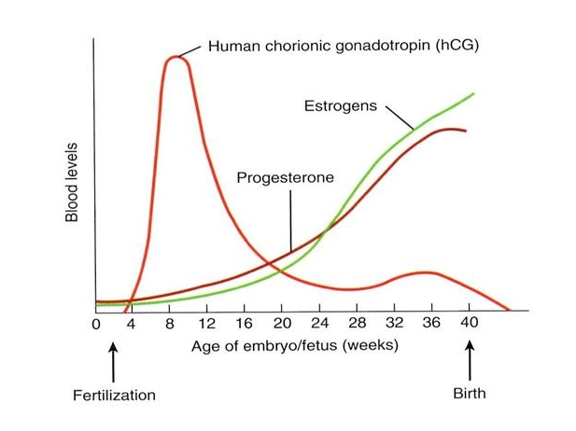

1. Which hormone/s shown above can be used to detect whether or not a woman is pregnant? (1 mark)

__________________________________________________________________

(b) Explain the role of hCG in pregnancy. (3 marks)

__________________________________________________________________­­

_________________________________________________________________­­­_­­­­

__________________________________________________________________

__________________________________________________________________

­­­__________________________________________________________________

The diagram below shows the movement of blood through a foetal heart.

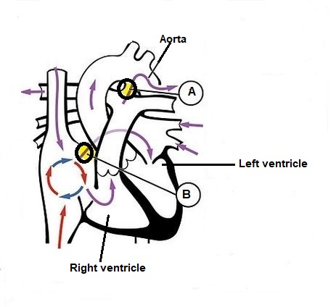

.

(c) The blood flow through a foetal heart is different to that in an adult heart. This is because two areas of the heart have been modified to assist with foetal blood flow.

Use the diagram to name and state the functions of the structures labelled A and B. (4 marks)

|  |  |  |
| --- | --- | --- |
| **Letter** | **Name** | **Function** |
| A |  |  |
| B |  |  |

(d) Describe how the foetal blood system is kept separate from that of the mother.

(2 marks)

__________________________________________________________________­­

_________________________________________________________________­­­_­­­­

__________________________________________________________________

(e) Explain the roles of prolactin and oxytocin in breastfeeding. (4 marks)

__________________________________________________________________­­

_________________________________________________________________­­­_­­­­

__________________________________________________________________

__________________________________________________________________

­­­__________________________________________________________________

__________________________________________________________________

**Question 38 (17 marks)**

The diagram below shows the arrangement of muscles and bones in the upper arm.

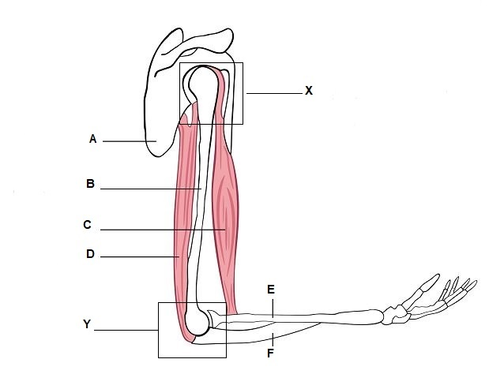

1. State the names of the structures labelled: (3 marks)

A ________________________________________________­

C ________________________________________________

E ________________________________________________

(b) Name the joints labelled X and Y and describe the difference in the range of

movement each joint allows. (4 marks)

__________________________________________________________________­­

_________________________________________________________________­­­_­­­­

__________________________________________________________________

__________________________________________________________________

­­­__________________________________________________________________

__________________________________________________________________

­­­

(c) The ends of bone are covered by cartilage. State the name of this type of cartilage and describe its function. (2 marks)

­­­_________________________________________________________________­­

_________________________________________________________________­­­_­­­­

__________________________________________________________________

__________________________________________________________________

­­­__________________________________________________________________

__________________________________________________________________

(d) All muscles possess three properties that allow them to work together to create movement. These are elasticity, extensibility and the ability to contract. Using the biceps and triceps muscles to illustrate your answer, explain why muscles need these three qualities to function effectively. (5 marks)

__________________________________________________________________­­

_________________________________________________________________­­­_­­­­

__________________________________________________________________

__________________________________________________________________

­­­__________________________________________________________________

__________________________________________________________________

__________________________________________________________________­­

_________________________________________________________________­­­_­­­­

__________________________________________________________________

(e) As a person ages they often suffer from a condition known as osteoarthritis. Describe **two** symptoms and **one** treatment for osteoarthritis. (3 marks)

__________________________________________________________________­­

_________________________________________________________________­­­_­­­­

__________________________________________________________________

**End of Section Two**

**Section Three: Extended answer 20% (40 Marks)**

This section contains **four** questions. You must answer **two** questions.

Questions 39 and 40 are from Unit 1. Questions 41 and 42 are from Unit 2. Answer **one** question from Unit 1 and **one** question from Unit 2.

Use a black or blue pen for this section. Only graphs and diagrams may be drawn in pencil. Responses can include: labelled diagram with explanatory notes; lists of points with linking sentences; labelled tables and/or graphs; and/or annotated flow diagrams with introductory notes.

Supplementary pages for planning/continuing your answers to questions are provided at the end of this Question/Answer booklet. If you use these pages to continue an answer, indicate at the original answer where the answer is continued, i.e. give the page number.

Suggested working time: 50 minutes.

**Unit 1**

Choose **either** Question 39 **or** Question 40.

Indicate the question you will answer by ticking the box next to the question. Write your answer on pages 30–34. When you have answered your first question, turn to page 35 and indicate on that page the second question you will answer.

**Question 39 (20 marks)**

1. Describe in detail the nature and location of the chemical processes involved in aerobic respiration. (8 marks)
2. Digestion involves the breakdown of large molecules into smaller ones so that

nutrients can be supplied to cells in a form that can be used for metabolic processes.

Explain how carbohydrates, proteins and fats are mechanically and chemically

digested. (12 marks)

**Question 40 (20 marks)**

1. Excess proteins are broken down in the body. The nitrogenous waste compounds

produced from these proteins are then excreted. Describe the processes involved in

breaking down proteins. Include in your answer a description of how and where the

nitrogenous waste compounds are produced, how they are transported and how

they are excreted. (10 marks)

1. Pepsin is an enzyme that is released into the acidic environment of the stomach.

Pepsin assists the breakdown of protein to amino acids. Explain how changes in

temperature and pH levels of the stomach will affect the action of pepsin in breaking

down proteins. (10 marks)

Question number: ________________

______________________________________________________________________________________________________________________________________________________

___________________________________________________________________________

___________________________________________________________________________

___________________________________________________________________________

___________________________________________________________________________

______________________________________________________________________________________________________________________________________________________

___________________________________________________________________________

___________________________________________________________________________

___________________________________________________________________________

___________________________________________________________________________

______________________________________________________________________________________________________________________________________________________

___________________________________________________________________________

___________________________________________________________________________

___________________________________________________________________________

___________________________________________________________________________

______________________________________________________________________________________________________________________________________________________

___________________________________________________________________________

___________________________________________________________________________

___________________________________________________________________________

___________________________________________________________________________

______________________________________________________________________________________________________________________________________________________

Question number: ________________

______________________________________________________________________________________________________________________________________________________

___________________________________________________________________________

___________________________________________________________________________

___________________________________________________________________________

___________________________________________________________________________

______________________________________________________________________________________________________________________________________________________

___________________________________________________________________________

___________________________________________________________________________

___________________________________________________________________________

___________________________________________________________________________

______________________________________________________________________________________________________________________________________________________

___________________________________________________________________________

___________________________________________________________________________

___________________________________________________________________________

___________________________________________________________________________

______________________________________________________________________________________________________________________________________________________

___________________________________________________________________________

___________________________________________________________________________

___________________________________________________________________________

___________________________________________________________________________

______________________________________________________________________________________________________________________________________________________

Question number: ________________

______________________________________________________________________________________________________________________________________________________

___________________________________________________________________________

___________________________________________________________________________

___________________________________________________________________________

___________________________________________________________________________

______________________________________________________________________________________________________________________________________________________

___________________________________________________________________________

___________________________________________________________________________

___________________________________________________________________________

___________________________________________________________________________

______________________________________________________________________________________________________________________________________________________

___________________________________________________________________________

___________________________________________________________________________

___________________________________________________________________________

___________________________________________________________________________

______________________________________________________________________________________________________________________________________________________

___________________________________________________________________________

___________________________________________________________________________

___________________________________________________________________________

___________________________________________________________________________

______________________________________________________________________________________________________________________________________________________

Question number: ________________

______________________________________________________________________________________________________________________________________________________

___________________________________________________________________________

___________________________________________________________________________

___________________________________________________________________________

___________________________________________________________________________

______________________________________________________________________________________________________________________________________________________

___________________________________________________________________________

___________________________________________________________________________

___________________________________________________________________________

___________________________________________________________________________

______________________________________________________________________________________________________________________________________________________

___________________________________________________________________________

___________________________________________________________________________

___________________________________________________________________________

___________________________________________________________________________

______________________________________________________________________________________________________________________________________________________

___________________________________________________________________________

___________________________________________________________________________

___________________________________________________________________________

___________________________________________________________________________

______________________________________________________________________________________________________________________________________________________

Question number: ________________

______________________________________________________________________________________________________________________________________________________

___________________________________________________________________________

___________________________________________________________________________

___________________________________________________________________________

___________________________________________________________________________

______________________________________________________________________________________________________________________________________________________

___________________________________________________________________________

___________________________________________________________________________

___________________________________________________________________________

___________________________________________________________________________

______________________________________________________________________________________________________________________________________________________

___________________________________________________________________________

___________________________________________________________________________

___________________________________________________________________________

___________________________________________________________________________

______________________________________________________________________________________________________________________________________________________

___________________________________________________________________________

___________________________________________________________________________

___________________________________________________________________________

___________________________________________________________________________

______________________________________________________________________________________________________________________________________________________

**Unit 2**

Choose **either** Question 41 **or** Question 42. Indicate the question you will answer by ticking the box next to the question. Write your answer on the pages provided.

**Question 41 (20 marks)**

(a) The male reproductive system consists of a number of structures that all contribute to the production and transport of sperm. Name and explain the role of the three accessory glands found in the male reproductive system. (12 marks)

(b) Lifestyle choices of a pregnant woman can often affect the development of a foetus. Explain how drinking alcohol, smoking cigarettes and dietary choices can impact foetal development. (8 marks)

**Question 42 (20 marks)**

(a) Describe the structure of DNA and the main steps in DNA replication within a cell. (11 marks)

(b) During embryonic development the inner cell mass of the blastocyst will

differentiate. The name given to a cell that can differentiate into any type of tissue is a ‘stem’ cell. Name the 3 types of stem cells, describe their potency and explain where they can be found. (9 marks)

**End of Questions**

Question number: ________________

______________________________________________________________________________________________________________________________________________________

___________________________________________________________________________

___________________________________________________________________________

___________________________________________________________________________

___________________________________________________________________________

______________________________________________________________________________________________________________________________________________________

___________________________________________________________________________

___________________________________________________________________________

___________________________________________________________________________

___________________________________________________________________________

______________________________________________________________________________________________________________________________________________________

___________________________________________________________________________

___________________________________________________________________________

___________________________________________________________________________

___________________________________________________________________________

______________________________________________________________________________________________________________________________________________________

___________________________________________________________________________

___________________________________________________________________________

___________________________________________________________________________

___________________________________________________________________________

______________________________________________________________________________________________________________________________________________________

Question number: ________________

______________________________________________________________________________________________________________________________________________________

___________________________________________________________________________

___________________________________________________________________________

___________________________________________________________________________

___________________________________________________________________________

______________________________________________________________________________________________________________________________________________________

___________________________________________________________________________

___________________________________________________________________________

___________________________________________________________________________

___________________________________________________________________________

______________________________________________________________________________________________________________________________________________________

___________________________________________________________________________

___________________________________________________________________________

___________________________________________________________________________

___________________________________________________________________________

______________________________________________________________________________________________________________________________________________________

___________________________________________________________________________

___________________________________________________________________________

___________________________________________________________________________

___________________________________________________________________________

______________________________________________________________________________________________________________________________________________________

Question number: ________________

______________________________________________________________________________________________________________________________________________________

___________________________________________________________________________

___________________________________________________________________________

___________________________________________________________________________

___________________________________________________________________________

______________________________________________________________________________________________________________________________________________________

___________________________________________________________________________

___________________________________________________________________________

___________________________________________________________________________

___________________________________________________________________________

______________________________________________________________________________________________________________________________________________________

___________________________________________________________________________

___________________________________________________________________________

___________________________________________________________________________

___________________________________________________________________________

______________________________________________________________________________________________________________________________________________________

___________________________________________________________________________

___________________________________________________________________________

___________________________________________________________________________

___________________________________________________________________________

______________________________________________________________________________________________________________________________________________________

Question number: ________________

______________________________________________________________________________________________________________________________________________________

___________________________________________________________________________

___________________________________________________________________________

___________________________________________________________________________

___________________________________________________________________________

______________________________________________________________________________________________________________________________________________________

___________________________________________________________________________

___________________________________________________________________________

___________________________________________________________________________

___________________________________________________________________________

______________________________________________________________________________________________________________________________________________________

___________________________________________________________________________

___________________________________________________________________________

___________________________________________________________________________

___________________________________________________________________________

______________________________________________________________________________________________________________________________________________________

___________________________________________________________________________

___________________________________________________________________________

___________________________________________________________________________

___________________________________________________________________________

______________________________________________________________________________________________________________________________________________________

Supplementary page

______________________________________________________________________________________________________________________________________________________

___________________________________________________________________________

___________________________________________________________________________

___________________________________________________________________________

___________________________________________________________________________

______________________________________________________________________________________________________________________________________________________

___________________________________________________________________________

___________________________________________________________________________

___________________________________________________________________________

___________________________________________________________________________

______________________________________________________________________________________________________________________________________________________

___________________________________________________________________________

___________________________________________________________________________

___________________________________________________________________________

___________________________________________________________________________

______________________________________________________________________________________________________________________________________________________

___________________________________________________________________________

___________________________________________________________________________

___________________________________________________________________________

___________________________________________________________________________

______________________________________________________________________________________________________________________________________________________

Spare Grid

|  |  |  |  |  |  |  |  |  |  |  |  |  |
| --- | --- | --- | --- | --- | --- | --- | --- | --- | --- | --- | --- | --- |
|  |  |  |  |  |  |  |  |  |  |  |  |  |
|  |  |  |  |  |  |  |  |  |  |  |  |  |
|  |  |  |  |  |  |  |  |  |  |  |  |  |
|  |  |  |  |  |  |  |  |  |  |  |  |  |
|  |  |  |  |  |  |  |  |  |  |  |  |  |
|  |  |  |  |  |  |  |  |  |  |  |  |  |
|  |  |  |  |  |  |  |  |  |  |  |  |  |
|  |  |  |  |  |  |  |  |  |  |  |  |  |
|  |  |  |  |  |  |  |  |  |  |  |  |  |
|  |  |  |  |  |  |  |  |  |  |  |  |  |
|  |  |  |  |  |  |  |  |  |  |  |  |  |
|  |  |  |  |  |  |  |  |  |  |  |  |  |
|  |  |  |  |  |  |  |  |  |  |  |  |  |
|  |  |  |  |  |  |  |  |  |  |  |  |  |

**ACKNOWLEDGEMENTS**

|  |  |
| --- | --- |
| **Section** | **Source** |
| Qu 5,6&7 | Digestive system [https://upload.wikimedia.org/wikipedia/commons/8/8a/](https://upload.wikimedia.org/wikipedia/commons/8/8a/Diagram_showing_the_parts_of_the_digestive_system_CRUK_324.svg)  Accessed September 2019 |
| Qu 14, 15 | Microscopic bone  <http://etc.usf.edu/clipart/50700/50764/50764_micro.htm>  Accessed August 2019 |
| Qu 17,18  &19 | <https://sites.google.com/site/pedigreesforpredictingtraits/volunteer-information>  Accessed August 2019 |
| Qu 31  Qu 31 | Transport of molecules by courtesy of examiner  <http://www.clker.com/clipart-animal-cell.html>  Accessed September 2019 |
| Qu 35 | Fertility rate data  Australian Bureau of Statistics.  <https://creativecommons.or/licenses/by/2.5/au>  Data extracted August 2019 |
| Qu 37 | <https://thealevelbiologist.co.uk/sexual-reproduction-humans/menstruation-gestation-and-lactation/>  accessed September 2019 |
| Qu 37 | <https://en.wikipedia.org/wiki/Fetal_circulation#/media/File:2916_Fetal_Circulatory_System-02.jpg>  accessed September 2019 |
| Qu 38 | Image showing bones and muscles of the upper arm  <https://www.shutterstock.com/image-vector/vector-main-bones-muscles-upper-arm-71402536>  Accessed September 2019 |